***YouTube Clone***

1. Requirements

* Video Upload
* View Uploaded videos
* Search videos
* Track stats of videos
* Comment on videos

1. Capacity Estimates

* Storage – 2.16PB per day
* Bandwidth – 3000 PB per day

1. Database Design

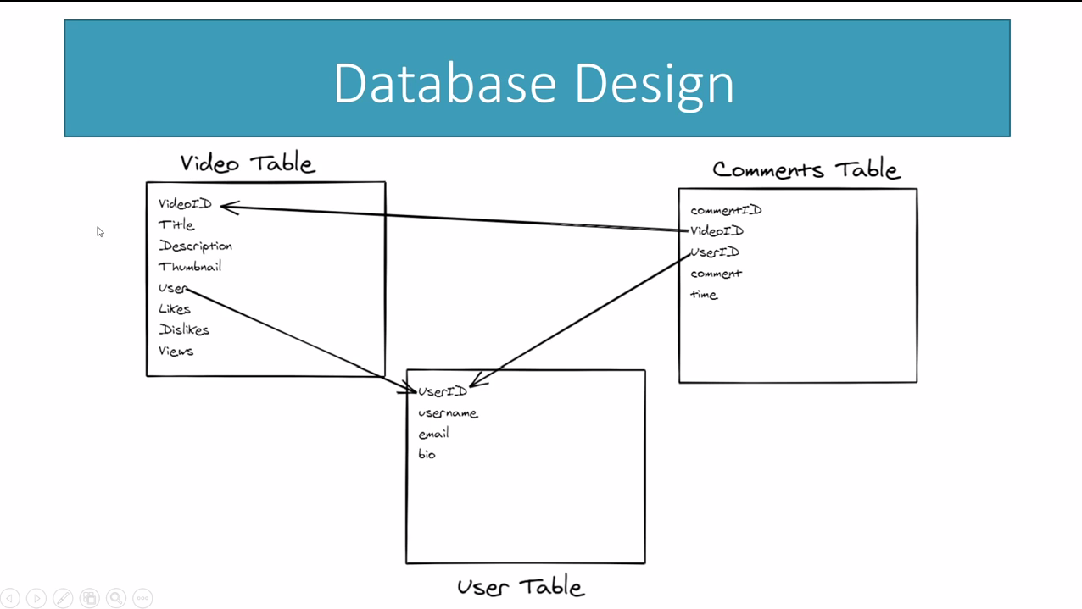

1. System Architecture

